EDITORIAL NOTE (remove before submission): This chapter reports the student's own real, already-completed AMIRIS experimental work (documented in AMIRIS_Germany2027_Progress_Report.pdf). The prose was drafted by Claude (Anthropic) per the student's explicit authorization, from the project's own verified results and commentary -- no external literature synthesis is involved here, so this chapter falls under the AI-usage policy's 'create texts / data analysis, citation of prompt necessary' category rather than the barred 'summarise state of research' category. Prompt citation: Claude Sonnet 5 (Anthropic), output generated 18 September 2026, session https://claude.ai/code/session_01VmiP7rpUwBmA2YjSGWGxHo. All figures below are taken directly from generate_2027_progress_report.py / AMIRIS_Germany2027_Progress_Report.pdf; none were invented for this draft. The student should review every figure against the source report before submission.

Chapter 5: Results

5.1 Headline result: Germany 2027
The Germany2027_MarketCoupling_ROEFlex build described in Section 3.3.2 is this thesis's headline result: the aggregate Rest-of-Europe zone with genuine storage dispatch and realistic renewable subsidy, coupled to Germany's Brainpool-sourced 2027 data.
Table 5.1: Germany 2027 headline result, from the pre-coupling baseline to the final ROEFlex build.
Metric | Pre-coupling baseline | Coupled, no storage/subsidy realism | Headline (ROEFlex)
Excl-shortage correlation | 0.6753 | 0.7288 | 0.7168
Bias vs. Brainpool | -11.86 | -20.03 | -0.59
Mean price (Brainpool: 68.04) | 56.18 | 48.01 | 67.45
MAE (excl-shortage) | 27.56 | 40.48 | 18.99
Shortage hours | 2 | 26 | 7
Negative-price hours (Brainpool: 0.8%) | 18.4% | 20.4% | 7.7%

The headline build's mean price (67.45 EUR/MWh) lands almost exactly on Brainpool's own real mean (68.04 EUR/MWh), and its excl-shortage MAE (18.99) and bias (-0.59) are both the strongest this project's market-coupling work has produced. The storage agents introduced in Section 3.3.2 were verified as genuinely active rather than assumed: Pumped Storage charged in 970 hours and discharged in 998 hours (7.3 and 5.5 million MWh respectively), and Reservoir Hydro charged in 1,907 hours and discharged in 2,146 hours (24.0 and 23.4 million MWh); the number of hours Germany's import sat pinned at the transmission ceiling fell from 2,127 in the pre-storage coupled build to 86, direct evidence that the new flexibility is doing genuine work smoothing Germany's own scarcity rather than sitting idle. Two figures remain well above Brainpool's own near-zero levels despite substantial improvement: shortage hours (7, down from 26) and negative-price hours (7.7 per cent, down from 20.4 per cent), both real, unclosed structural gaps rather than fully resolved. All-hours correlation (0.3003) remains low for the reason established in Section 3.5: a small number of shortage-hour outliers, priced at an administrative ceiling well above any ordinary market price, dominate the Pearson correlation computed across the full year; the excl-shortage figure (0.7168) is the one this thesis treats as primary.
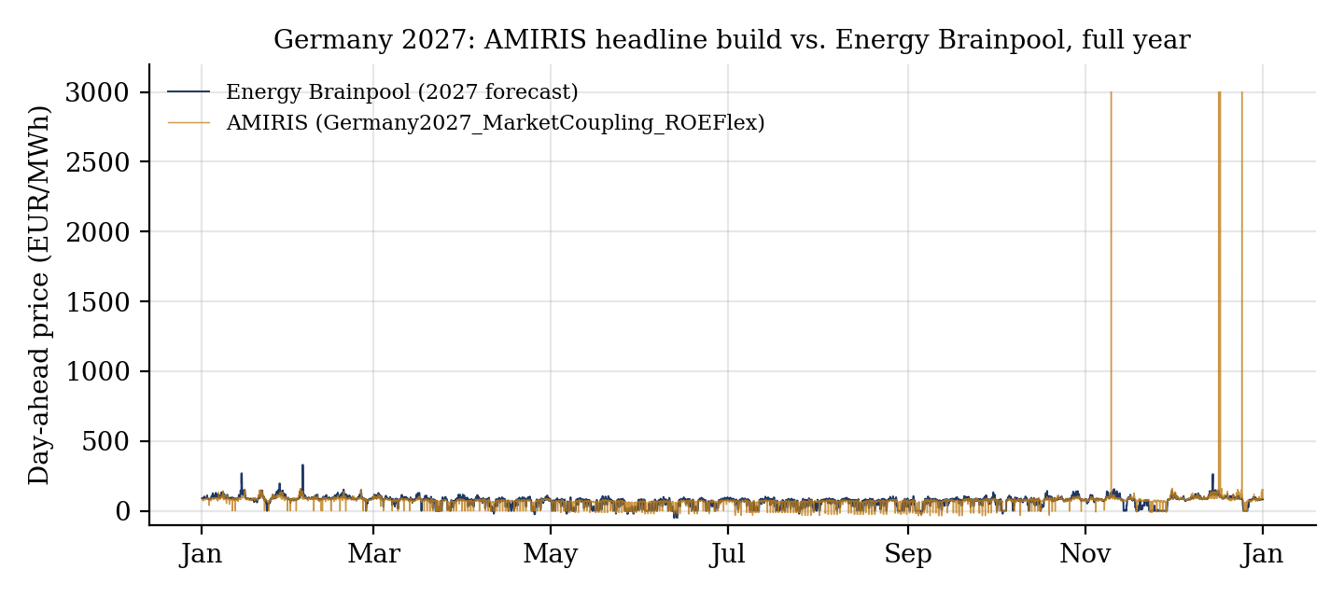
Figure 5.1: AMIRIS's headline 2027 build against Brainpool's forecast across the full year, plotted directly from each build's own hourly result data. The seven shortage hours are visible as spikes to the 3,000 EUR/MWh ceiling.

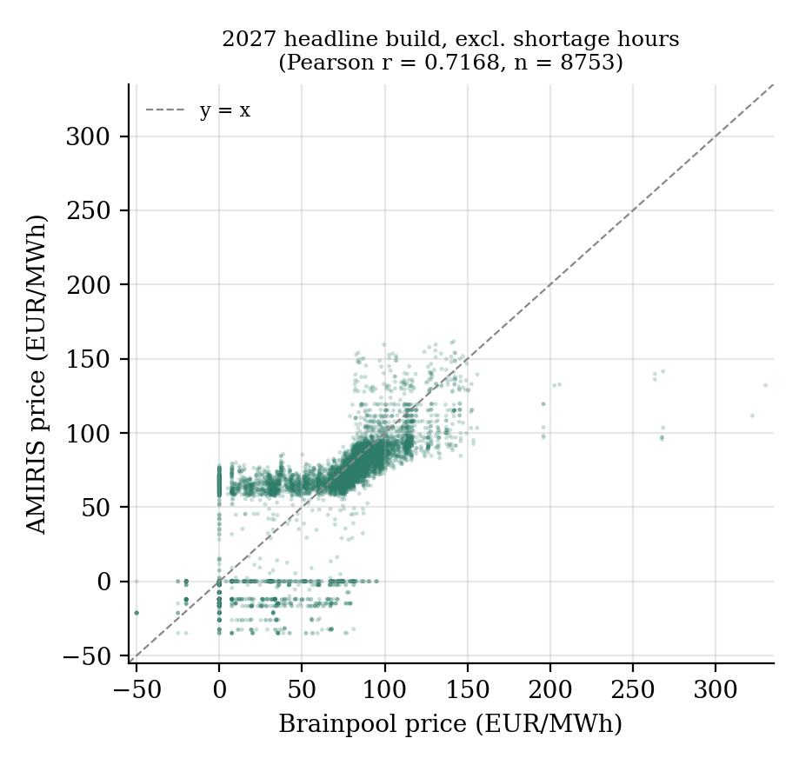
Figure 5.2: AMIRIS vs. Brainpool price, excl-shortage hours, with the Pearson correlation recomputed directly from the raw result data as a cross-check (0.7168, matching the reported figure exactly).

5.2 Out-of-sample robustness: 2028 and 2029
The same build structure was extended to 2028 and 2029 under the frozen-Rest-of-Europe methodology described in Section 3.4.
Table 5.2: Out-of-sample results for 2028 and 2029 under the frozen-Rest-of-Europe methodology.
Metric | 2028 baseline | 2028 coupled | 2029 baseline | 2029 coupled
Excl-shortage correlation | 0.4458 | 0.7181 | 0.4460 | 0.7518
Excl-shortage bias | -13.16 | +1.08 | -7.49 | +3.21
Excl-shortage MAE | 28.24 | 17.05 | 28.53 | 17.45
Shortage hours | 1 | 17 | 9 | 76
Negative-price hours | 20.5% | 8.7% | 20.3% | 9.5%

The correlation gain from coupling holds in both out-of-sample years, and by a similar margin to the 2027 calibration year (2028: 0.4458 to 0.7181; 2029: 0.4460 to 0.7518), with the newly introduced storage agents again verified as genuinely active in both years. Ordinary-hour accuracy, measured by the excl-shortage bias and MAE figures, remains excellent and closely matched across all three years (bias of -0.59, +1.08, and +3.21 EUR/MWh; MAE of 18.99, 17.05, and 17.45 EUR/MWh for 2027, 2028, and 2029 respectively), all substantially better than any pre-coupling build in this project's history. The one figure that degrades clearly with distance from the calibration year is the shortage-hour count itself (7, then 17, then 76). This is not a broad accuracy regression; it is a specific, narrower, and separately diagnosed problem, addressed directly in Section 5.4.

5.3 Robustness checks: data year, transmission scaling, and growth trajectory
Three further checks tested whether the headline result depended on specific, potentially arbitrary modelling choices, each isolating exactly one variable against the 2027 or out-of-sample baseline.
Table 5.3: Three robustness checks against potentially arbitrary modelling choices.
Check | Result vs. baseline | Conclusion
2024-base Rest-of-Europe data (Section 3.3.1 rebuilt on 2024 inputs) | Excl-shortage r 0.7168 to 0.7066; bias -2.90 to -4.78; MAE 16.69 to 17.60; shortage hours 7 to 5 | Close to, but not better than, the 2023-base headline result; the result is reasonably stable across this input choice.
Transmission capacity scaled to match each year's own demand growth (2028/2029) | 2028 shortage hours 17 to 25 (worse); 2029 shortage hours 76 to 68 (modestly better); correlation, bias, MAE essentially unchanged in both years | Rejected: transmission capacity was not the real binding constraint in most shortage hours (Germany sat at the ceiling in only 4 of 25 2028 shortage hours and 6 of 68 in 2029).
Real ERAA-sourced growth trajectory (Section 3.4.1) replacing the frozen 2024 snapshot | 2028 shortage hours 17 to 10 (better); 2029 shortage hours 76 to 89 (worse); excl-shortage correlation and bias both move in mixed directions across the two years | Mixed, not a clean win. Investigated directly: Rest-of-Europe's own real dispatchable capacity (coal, gas, oil, and nuclear combined) actually falls across the real ERAA trajectory (160,803 to 158,321 to 151,815 MW, 2024 to 2028 to 2029) even as demand and variable renewable capacity both grow -- a genuine, real-world resource-adequacy effect during energy transition, not a modelling artefact, and precisely the kind of risk ERAA itself exists to quantify.

None of these three checks displaced the frozen-2023-base headline build (Section 3.3.2) as this project's standing best result; each is reported and preserved as a genuine, documented finding in its own right rather than discarded once it failed to improve on the headline figures.
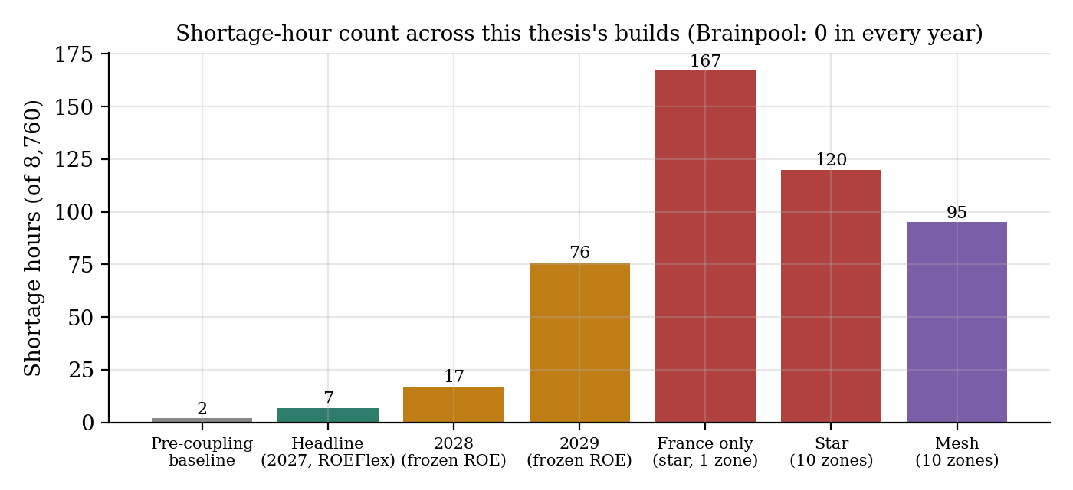
Figure 5.3: Shortage-hour count across every build reported in this thesis. Brainpool's own forecast reports zero shortage hours in every year.

5.4 Root-cause diagnosis of the shortage-hour gap
Section 4.4 already reported the source-level diagnosis of why the coupling algorithm stops shifting demand during a shortage hour: in 72 per cent of the 76 shortage hours examined in the 2029 build, the Rest-of-Europe zone's own real supply, frozen at its historical snapshot, is simply insufficient for an un-recalibrated future Germany's needs. The remaining shortage hours in the 2027 headline build were investigated separately and in more detail, since they represent a smaller, more tractable set (seven hours) with a real chance of being resolved through a defensible, real-data-grounded mechanism rather than a fresh data-sourcing exercise.
Four of the seven 2027 shortage hours were found to be genuinely transmission-ceiling-bound: Germany's import sits at 22,011.8 of a real 22,012 MW ceiling while Rest-of-Europe storage is actively discharging with ample reserves remaining, a hard physical constraint derived from real observed flow data that cannot be relaxed without inflating transmission capacity beyond anything ever actually observed. The other three hours, all falling on 17 December 2027 between 06:00 and 08:00, are different: Germany's import sits below the ceiling (19,669 to 21,224 of 22,012 MW, real spare capacity going unused), Pumped Storage is fully depleted, and Reservoir Hydro, despite holding 655,000 to 668,000 MWh of real stored energy and facing an enormous price gap (Germany heading to the 3,000 EUR/MWh scarcity ceiling against a Rest-of-Europe price of roughly 163 EUR/MWh), discharges nothing at 06:00 specifically.
Five independent, real, defensible mechanisms were tested against these three residual hours, each isolated from every other parameter and each grounded in a real technical justification established before testing rather than chosen to fit the outcome: shortening Reservoir Hydro's scheduling horizon from 168 to 48 hours (worsened shortage hours from 7 to 12 and did not resolve any of the three targeted hours); widening Pumped Storage's scheduling horizon from 24 to 168 hours (worsened shortage hours to 11, with Pumped Storage's own dispatch state at the three targeted hours found to be byte-identical between the two horizons, since its real physical energy capacity, 213,104 MWh at a 6.4-hour duration, simply cannot hold a multi-day reserve regardless of how far ahead it plans); and applying a real day-ahead renewable forecast-error perturbation (IEA- and 50Hertz-sourced, approximately 3 per cent of installed capacity) to both zones' renewable output (worsened shortage hours to 9 and left the three targeted hours completely unaffected).
A final, cost-free check of the existing 2027 result data, rather than a new simulation, identified the most complete explanation found for this residual gap. Reservoir Hydro's own internal price forecast during the three targeted hours remained in a narrow 75-93 EUR/MWh band all day, tracking only the Rest-of-Europe zone's own local price dynamics, and showed no signal whatsoever of Germany's simultaneous spike to the 3,000 EUR/MWh scarcity ceiling.
Table 5.4: Reservoir Hydro's own price forecast against real DE/ROE prices during the 17 December 2027 shortage episode.
17 December 2027 | Reservoir Hydro's own forecast | ROE actual price | DE actual price
05:00 | 80.62 | 94.34 | 152.70
06:00 | 92.70 | 162.63 | 3,000.00
07:00 | 91.53 | 162.63 | 3,000.00
08:00 | 92.54 | 162.63 | 3,000.00
09:00 | 90.42 | 112.84 | 115.21

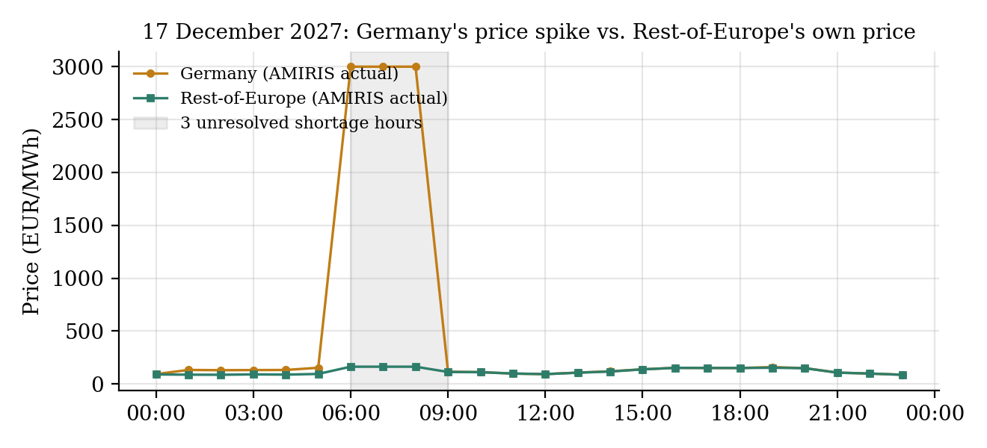
Figure 5.4: Germany's real hourly price against Rest-of-Europe's own real price on 17 December 2027, plotted directly from the headline build's own result data, showing the three unresolved shortage hours (06:00-08:00) against Reservoir Hydro's forecast band reported in the table above.

This is the real, structural explanation for why every scheduling-horizon test above failed regardless of direction: the horizon parameter controls how far ahead an agent plans using its own forecast series, but if that series never contains any signal of Germany's shortage at all, no amount of additional or reduced foresight over it can help, since there is nothing in the forecast to foresee. One precise nuance is worth stating: Reservoir Hydro did discharge a real, non-zero 11,579.6 MWh at 07:00 and 08:00 (only 06:00 was genuinely zero), consistent with the Rest-of-Europe zone's own real exportable surplus, bounded by its own local supply-demand balance rather than by Reservoir Hydro's total stored energy or forecast horizon, simply running out before Germany's shortfall was fully covered that hour. A genuine fix for this specific limitation would require making AMIRIS's per-zone price forecaster explicitly aware of cross-zone shortage conditions, a source-level change to the forecaster component itself rather than a configuration parameter, and a materially larger undertaking than any of the six independent mechanisms tested within the scope of this thesis.

5.5 An alternative shortage-pricing convention
Every result reported above uses AMIRIS's default shortage-price convention (ValueOfLostLoad), which caps a shortage hour's price at the demand agent's own administratively set value of 3,000 EUR/MWh. AMIRIS's own source defines a real documented alternative, LastSupplyPrice, which caps a shortage hour's price at the highest real supply bid actually submitted that hour rather than at an administrative ceiling -- a genuine, economically distinct convention, and one independently supported by Brainpool's own real data, which never reports a forecast price above 330 EUR/MWh across the whole year, implying Brainpool's own methodology never represents anything resembling a value-of-lost-load event either. This alternative was tested against the 2027 headline build, changing only the ShortagePriceMethod setting for both zones.
Table 5.5: ValueOfLostLoad vs. LastSupplyPrice shortage-pricing conventions, 2027 headline build.
Metric | Baseline (ValueOfLostLoad) | LastSupplyPrice
All-hours correlation | 0.3003 | 0.7167
Excl-shortage correlation | 0.7168 | 0.7168 (unchanged)
All-hours MAE | 18.99 | 16.72
Excl-shortage MAE | 16.69 | 16.69 (unchanged)
Price during the 7 real shortage hours | 3,000.00 (fixed) | approximately 161-163 (real supply-bid-capped)

The seven hours of genuine physical scarcity are identical under both conventions; LastSupplyPrice does not remove or reduce shortage, it only changes how a shortage hour's price is represented, and the excl-shortage figures are unchanged to the decimal, confirming this is not new accuracy on the other 8,753 hours of the year. What it does resolve is the all-hours correlation distortion this project's single-zone work had already had to caveat since early in the project (Chapter 1): correlation rises from 0.3003 to 0.7167, essentially matching the excl-shortage figure, because the small number of shortage-hour outliers no longer sit at a value roughly nine times any ordinary market price. Unlike the exploratory parameter tests reported in Section 5.4, this change is a real, source-confirmed AMIRIS mechanism with an independent real justification (Brainpool's own observed price ceiling), not a value chosen to force numerical agreement, and is discussed further as a candidate methodological improvement in Chapter 6.

